NEW HAMPSHIRE
DEPARTMENT OF STATE

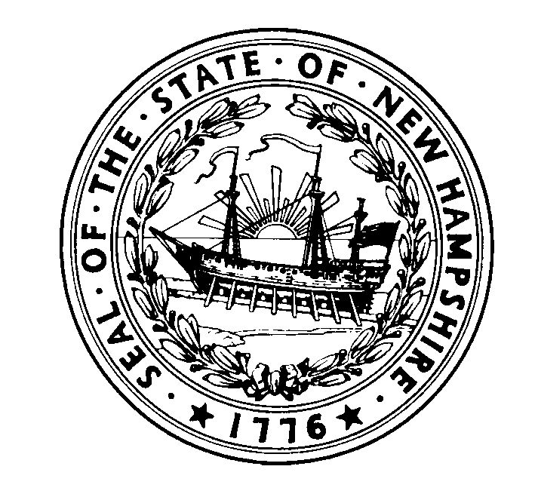
Robert P. Ambrose
Senior Deputy Secretary of State

David M. Scanlan
Deputy Secretary of State

Anthony B. S. Stevens
Assistant Secretary of State
William M. Gardner
Secretary of State

May 13, 2016
To: Brent Turner (California Association of Voting Officials)
Re: one4all, New Hampshire’s Open Source Accessible Voting System
Following the passage of the Help America Vote Act of 2002 (“HAVA”), the New Hampshire Department of State initiated a planning process to satisfy HAVA Section 301, requiring an accessible voting system , by involving election officials and a range of persons with disabilities. When we found that potential users of such a system could not agree on a preferred system, we decided to proceed with a cost-effective and workable solution, with an explicit plan to replace it when we found a system more satisfactory to all.

In 2014, we found a version of open source software that Dr. Juan Gilbert and his Prime III team had made available to the public. With the active support of Dr. Gilbert’s Prime III team and the good work of the California Association of Voting Officials, we used it in several pilots in New Hampshire polling places in both the 2014 State Primary and General Election. People with disabilities and election officials responded very positively.

With that experience behind us, we decided to implement the system statewide in the 2016 Presidential Primary and henceforth. We conducted more user testing, obtained valuable input from the disabilities community and election officials, and designed architecture relying on our internal staff. We used the assistance of the Prime III team to make certain software changes. As time went on, we relied more heavily on our own staff and New Hampshire people with disabilities to revise and improve the user interface, ultimately naming the New Hampshire system one4all, reflecting our interest in making this available to a wide variety of individuals – one that is not limited solely to the disabilities community. We believe this goal is in the interest of all participants, because having more users ensures more voter privacy.

We purchased commercial off-the-shelf Dell tablets, Brother Printers and other equipment, programmed the Dell tablets with our ballots, distributed the equipment to all of our towns and cities, and trained election officials to use the equipment.

Relying substantially on our internal staff, we are continuing to solve challenges with this system. The beauty of the system is the flexibility of open source and the capacity we develop over time to change the system to reflect user needs. And, of course, it is a small fraction of the cost of the vendor-supplied systems in the marketplace. We look forward to further developing this product in the coming years.

Sincerely yours,
William M. Gardner

