Next Generation VVSG Scope and Structure
Request for Comments
08/18/2016
Table of Contents
Next Generation VVSG Scope (Use Case Scenarios) 3
Introduction 3
Request for Feedback 3
Overview of Focus Areas 3
Electronic Pollbooks (EPBs) 5
Ballot Delivery (BD) 7
Ballot on Demand (BoD) 9
Ballot Marking (BM) 11
Auditing 12
Election-Night Reporting (ENR) 13
Next Generation VVSG Structure 15
Introduction 15
Request for Feedback 15
Overview 15
1. Usability and Accessibility Principles and Guidelines 16
Principle 1: Equivalent and consistent 16
Principle 2: Cast as marked 16
Principle 3: Marked as intended 16
Principle 4: Tested for usability 17
Principle 5: Meets web accessibility standards 17
2. Human Factors Analysis 17
Human Factors Challenges 17
Incorporate Latest Research 17
New Devices: Beyond Kiosks 18
New Interfaces 18
New Interactions 18
3. Usability and Accessibility Requirements Analysis 19
PRINCIPLE 1: EQUIVALENT AND CONSISTENT 19
PRINCIPLE 2: CAST AS MARKED 21
PRINCIPLE 3: MARKED AS INTENDED 24
PRINCIPLE 4: TESTED FOR USABILITY 33
PRINCIPLE 5: MEETS WEB ACCESSIBILITY STANDARDS 34
4. Structure of the Standard 35
Proposed Format 35
Clear Sections of Information 35
Navigation in the Web Page View 36
5. Example using Principle 3 37

Next Generation VVSG Scope (Use Case Scenarios)

Introduction

This document provides a summary of the focus areas for development of the Next Generation VVSG by the NIST Voting Public Working Groups. These focus areas were identified during the February, 2016 TGDC meeting. For each area, we highlight the typical use case scenario as well as common variations. They represent starting points for discussion, not necessarily areas to be included in the standard in totality. As such, we need to determine which areas or subareas are in scope for this ongoing work.
Specifically, we are requesting your feedback regarding which use case scenarios should be included in the development of the Next Generation VVSG.

Request for Feedback

For each use case scenario, please address these questions:

- Is the use case scenario in scope for the Next Generation VVSG for development of requirements that will undergo testing and certification? or
- Is the use case scenario in scope to develop as guidelines for election officials and voting system manufacturers? or
- Is the use case scenario not in scope for this work?
- If different parts of the use case scenario fall in 1., 2., and/or 3. Please identify as such.
- Is anything missing?

Overview of Focus Areas

Each area is defined by the processes and functions it supports. The set of identified use-cases are also, in some cases, highly interdependent. Thus, a given function may occasionally be reused in more than one case.

The current set of use case scenarios include:
- Electronic Pollbooks (EPB)
- Ballot Delivery (BD)
- Ballot on Demand (BoD)
- Ballot Marking (BM)
- Auditing (AUDIT)
- Election Night Reporting (ENR)

The following diagram visualizes the use-cases in the context of a typical election process. The accompanying table describes the meaning of each abbreviation used throughout this document.

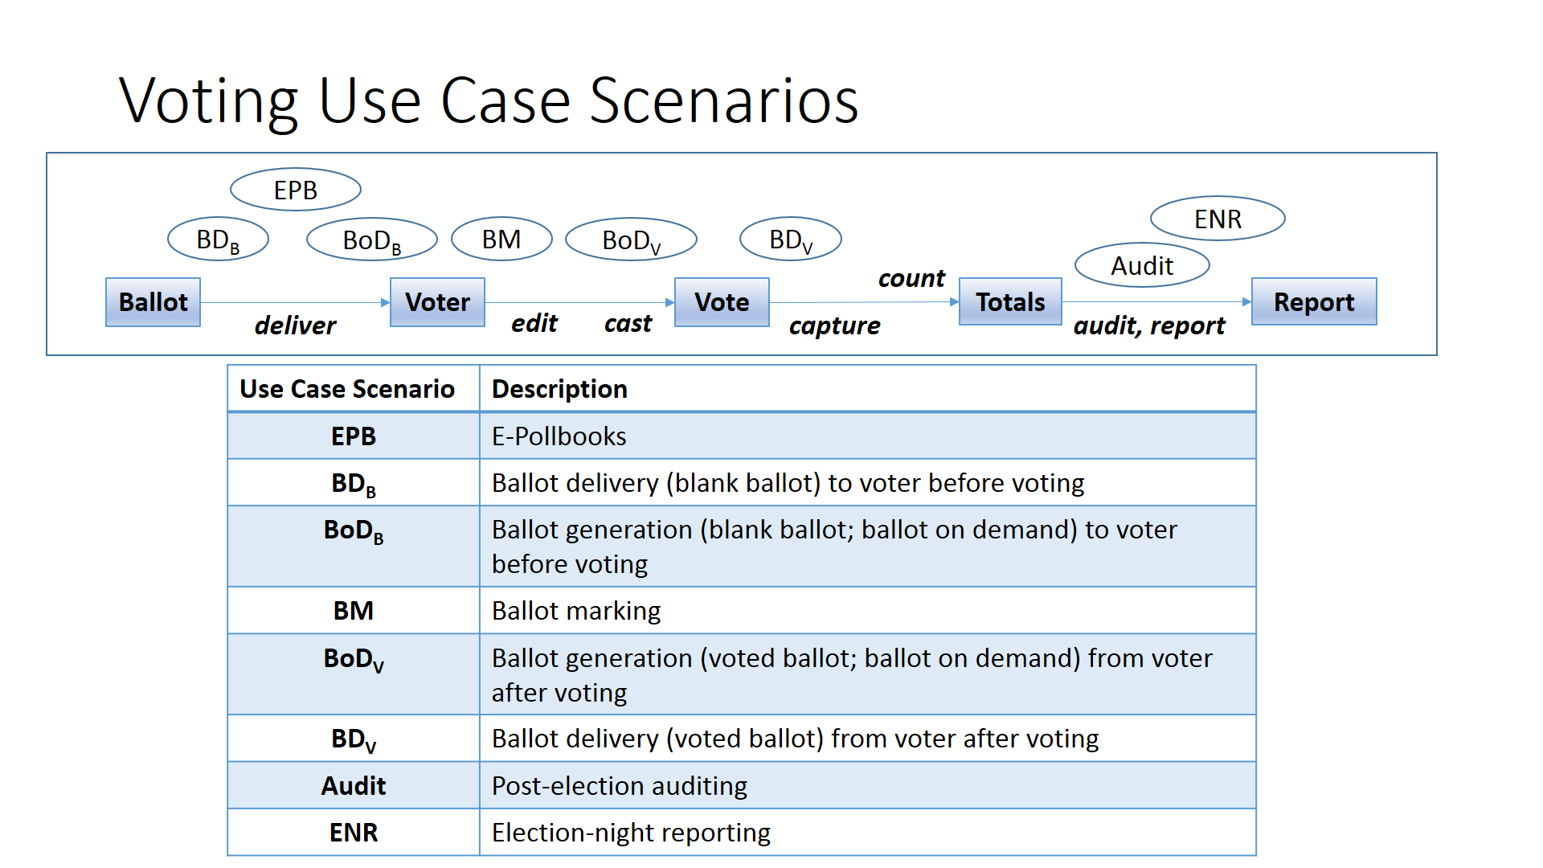

Electronic Pollbooks (EPBs)

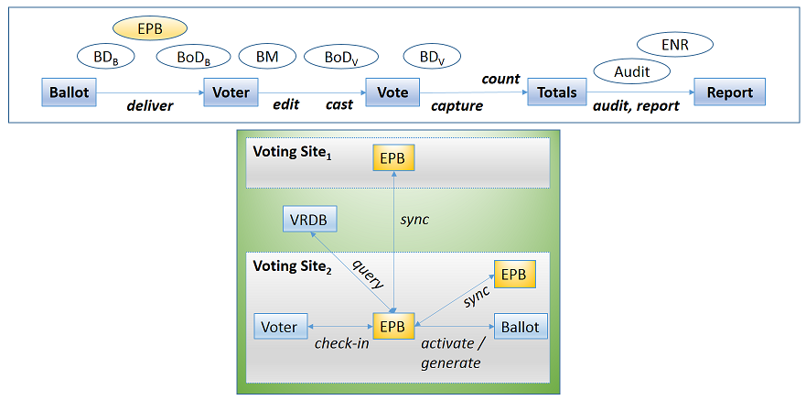

The purpose of electronic pollbook (EPB) technology is to identify voters and manage their ballots during election operations. Most typically this involves being able to check-in a voter at a given voting location and, depending on the EPB’s technology platform, it may also able to activate a voter’s ballot before they vote on it. Traditionally, these capabilities were made possible via the EPB’s use of voter registration data, which was often pre-loaded on the EPB so it could function in an offline, standalone mode during the election. In other cases, an EPB is able to access this data via a direct, online connection to its corresponding voter registration system. In still other cases, EPB units may be used at multiple voting locations (e.g., vote centers, etc.) and may be able to connect and synchronize with one another, sharing information such as what voters have checked-in and/or voted at particular locations. In addition to these variations, an EPB may support many additional functions ranging from merely looking up/verifying voter information to supporting ballot generation, activation, as well as others. Thus, in this particular form, an EPB begins to appear as a general election operations technology integration platform. In such cases, it inherits the roles, functions, and responsibilities of its dependent use-cases.
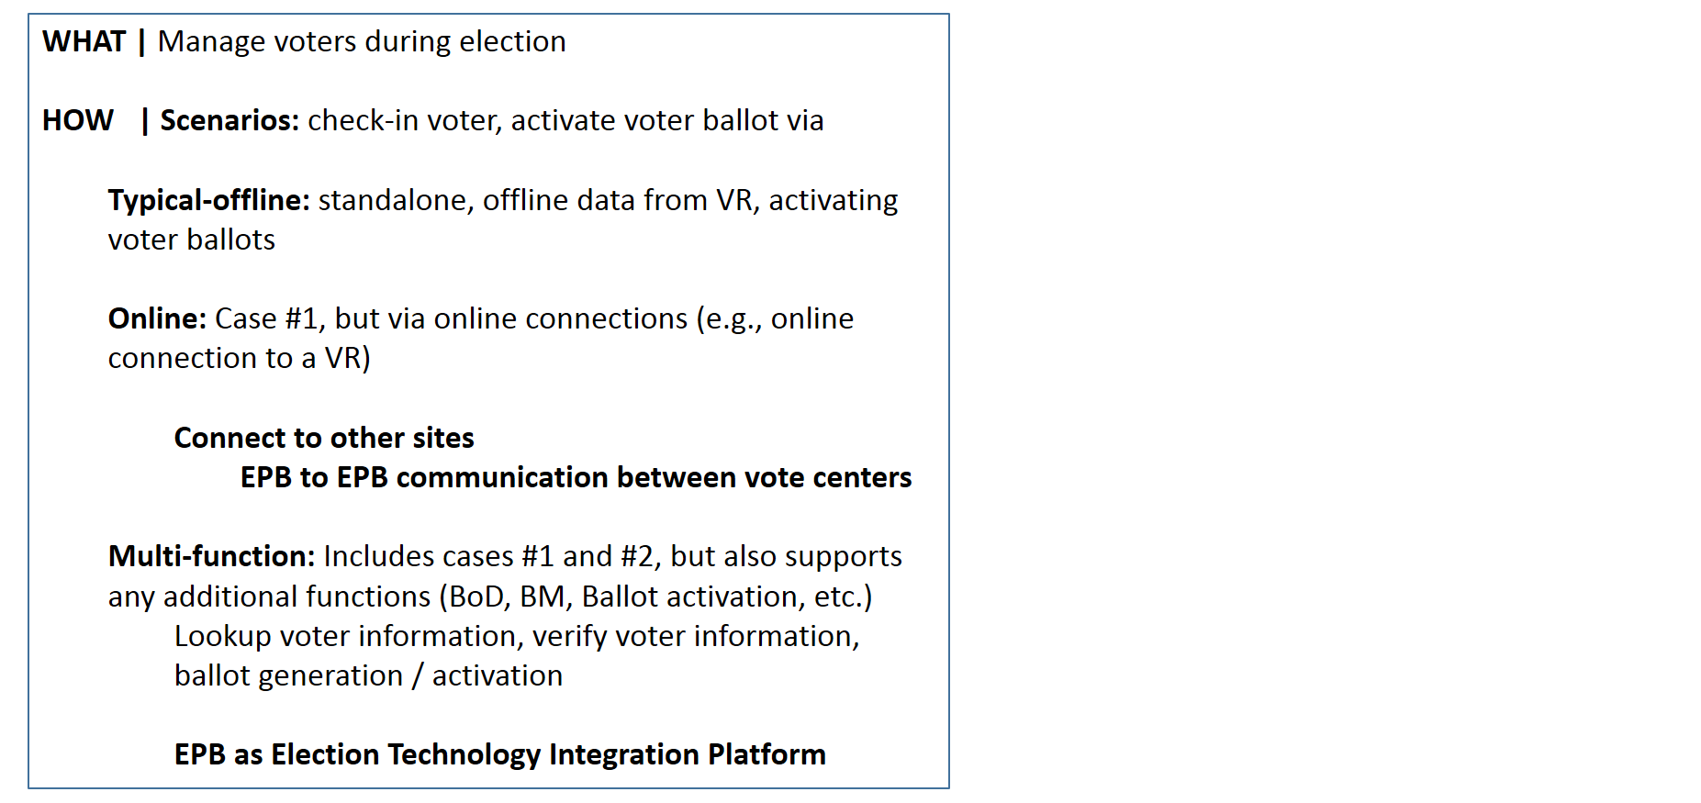

Ballot Delivery (BD)

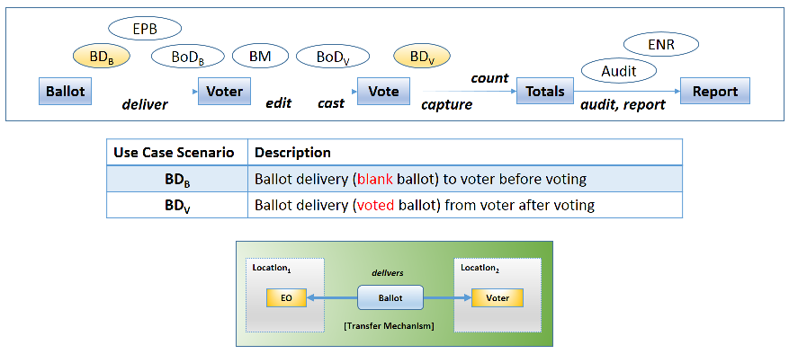

The purpose of ballot delivery (BD) technology is to deliver an appropriate ballot to a given voter via a ballot delivery mechanism (such as the USPS/mail system or alternative electronic transport mechanisms, such as email, website download, etc.). Most typically one will think of the need to deliver blank ballots to voters from a given election office. Paper-based absentee ballots are very common in this case. However, it is becoming increasingly common to encounter electronic blank ballot delivery, particularly in UOCAVA and similar contexts. In such cases, voters would be provided with ways to receive and access a blank electronic ballot, say, via their email, website download of the blank ballot, etc. Potentially voters receiving such an electronic ballot could receive it via many different possible personal devices, be they standalone personal computers, tablets, laptops, and/or “smart devices” (e.g., smartphones, etc.). Although paper-based ballots are typically transferred via “the mail system”, the trajectory of a given ballot in such spaces may include many different mail systems (USPS, military mail system) and different physical transport mechanisms (by land, sea, train, air, etc.). Over time, the use of voted ballot return (a.k.a., voted ballot delivery) has become more prevalent. Even though it has the same delivery/transport mechanisms available to it, the primary concern for voted ballot delivery is how to return voted ballots in a most secure fashion. So far, mail has been the transport mechanism of choice for absentee voters. Similar to BoD, voters and election officials may have various reasons to desire an ability to create or convert existing ballot representations into alternative formats.

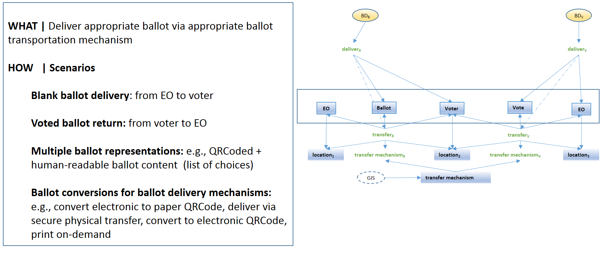
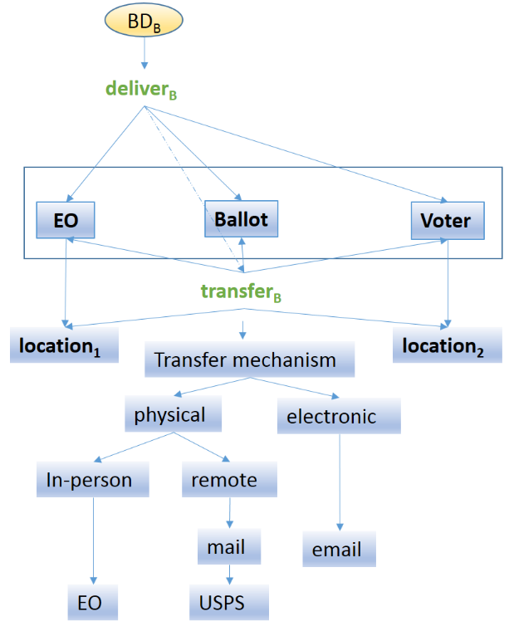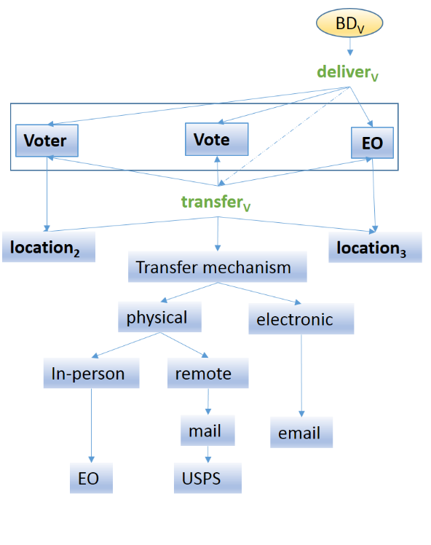

Ballot on Demand (BoD)

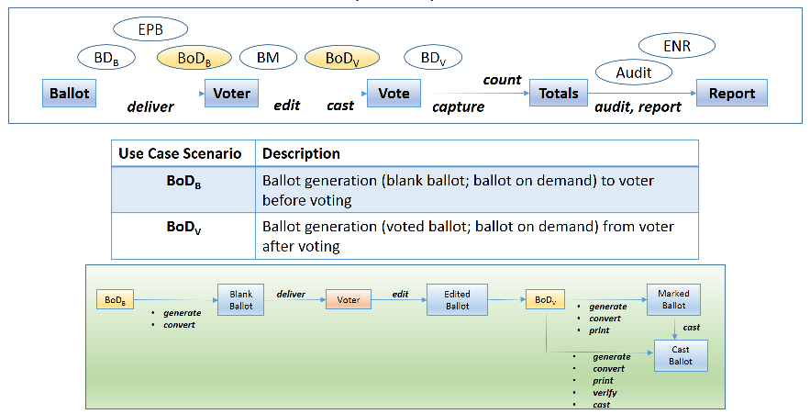

The purpose of ballot on demand (BoD) technology is to create an appropriate ballot for a voter at the time when they request it. The most typical scenario for this case is blank-ballot creation. This is typically encountered as an offline capability to create, for example, blank paper ballots via ballot printing during in-person voting at a polling place. Blank-ballot creation may take place at locations other the polling place such as when a voter prints their own paper ballot during absentee voting at home. Alternatively, BoD may be used after a voter selects their choices in order to create a voted ballot. This may often be seen in cases where ballot marking and ballot creation functions are co-located, such as in modern ballot marking devices which enable voters to mark and subsequently print voted paper ballots. The voted ballot creation scenario may also have alternative contexts, such as an equivalent ballot creation scenario for absentee voters marking and printing paper ballots using their personal device(s). In addition to the ability to create (generate) paper/printed ballots in these and related contexts, one may need to create blank or voted ballots in one or more alternative ballot representations, be they in the form of QRCodes, text-based ballot and choice listings, or others. In this role, a BoD device may support the ability to create multiple ballot representations and/or the ability to convert among multiple allowed ballot representations.
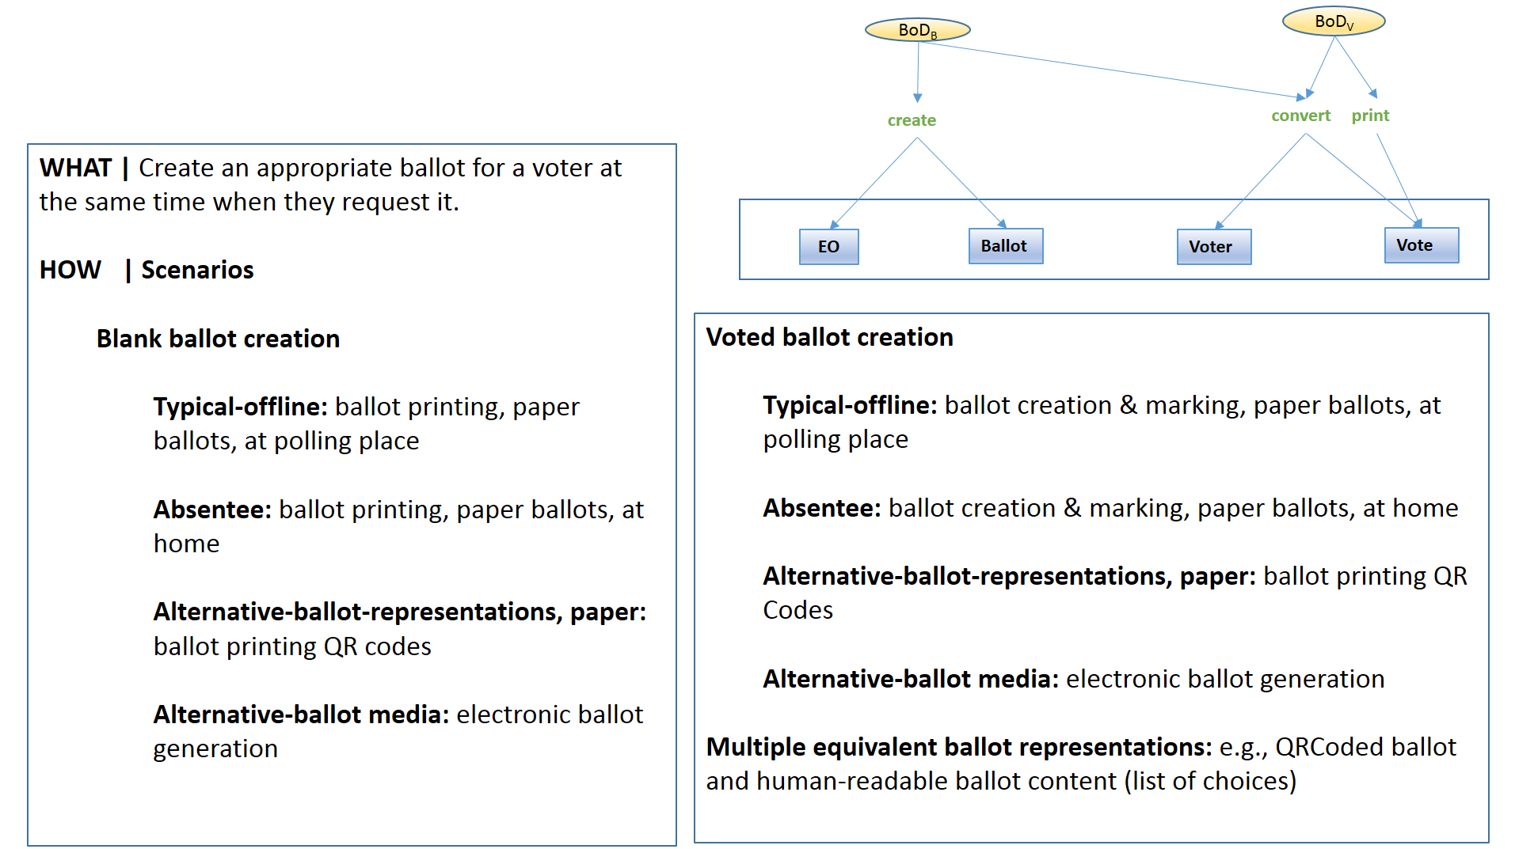

Ballot Marking (BM)

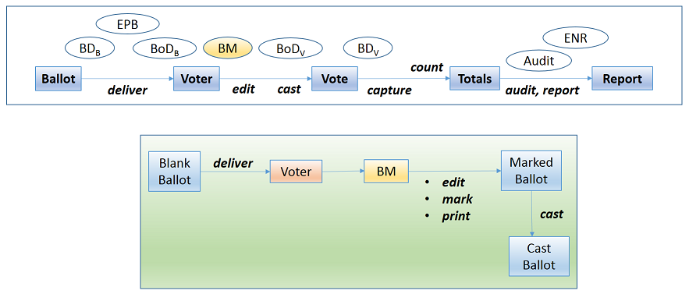

The purpose of ballot marking (BM) technology is to enable a voter to validly mark their ballot via a ballot marking mechanism. The simplest example of ballot marking is the scenario wherein a voter manually marks their paper ballot using a pen as their ballot marking mechanism. This may be performed either during in-person voting at a polling-place or at some absentee location, such as at a voter’s home. Alternatively, a voter may vote in-person using a ballot marking device (BMD) wherein they make their ballot selections using a touchscreen (or equivalent) interface and can subsequently render/print those selections onto a given ballot representation (such as a printed paper ballot). Over time, new forms of BMD, such as remote ballot marking devices have become available to enable absentee voters to mark their ballots, say, from home in an equivalent manner to voters voting in-person using a BMD. In such a case, the printing step may occur on a voter’s own device or may, alternatively, replace the traditional ballot printing function with rendering the voter’s choices into an alternative electronic ballot representation, such as PDF. Just as with BoD and BD scenarios, voters and EOs may encounter the need to create and/or convert a given ballot representation into one-or-more equivalent representations so as to support additional ballot processing activities.

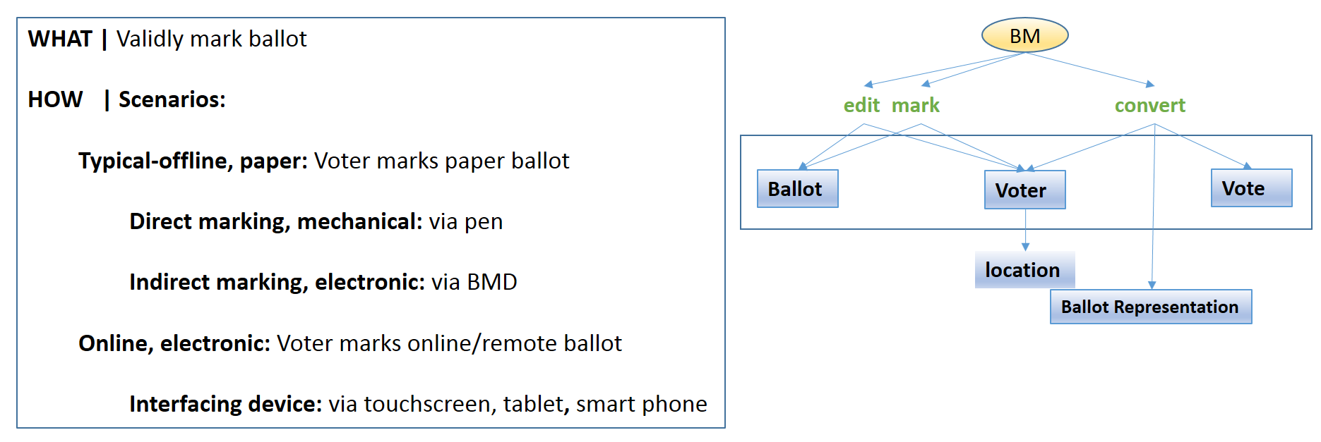

Auditing

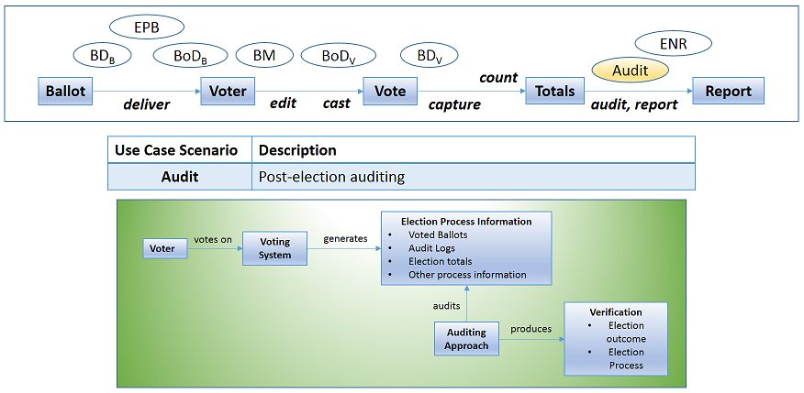

The most essential purpose of post-election auditing technology is to verify election outcomes as well as how those outcomes were produced. Typically, this may be done in a completely offline manner. A full recount occurs in the case when every voter-verified ballot that was cast, counted, and reported upon is recounted for a given election. Such a process may be employed as a means for checking whether or not originally reported outcomes and recounted outcomes are the same. To perform full recounts is a lengthy, manual, and potentially error-prone process. To minimize possible causes of error, one may perform various kinds of audits, such as risk-limiting audits, which do not necessarily require a full recount, but are designed to have equivalent power to verify election outcomes when given an appropriate (representative, random) sample of an election’s voter-verified/cast ballots. Typically, a risk-limiting audit may be performed by examining single-ballots. However, multiple-ballot (batch) auditing may also be performed. Finally, this use case may also provide the opportunity for discussion of additional auditing types or approaches as well. Different auditing approaches may make use of different kinds of election process information and utilize different strategies in order to establish their conclusions.
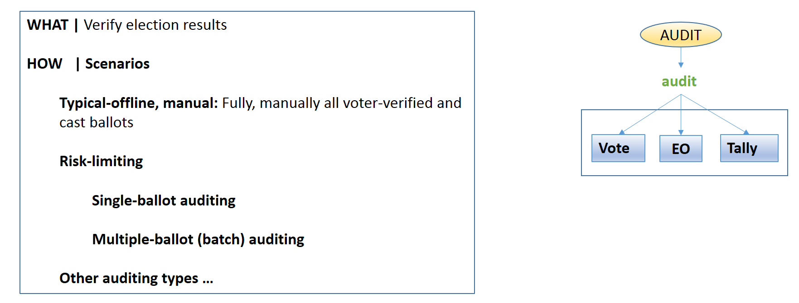

Election-Night Reporting (ENR)

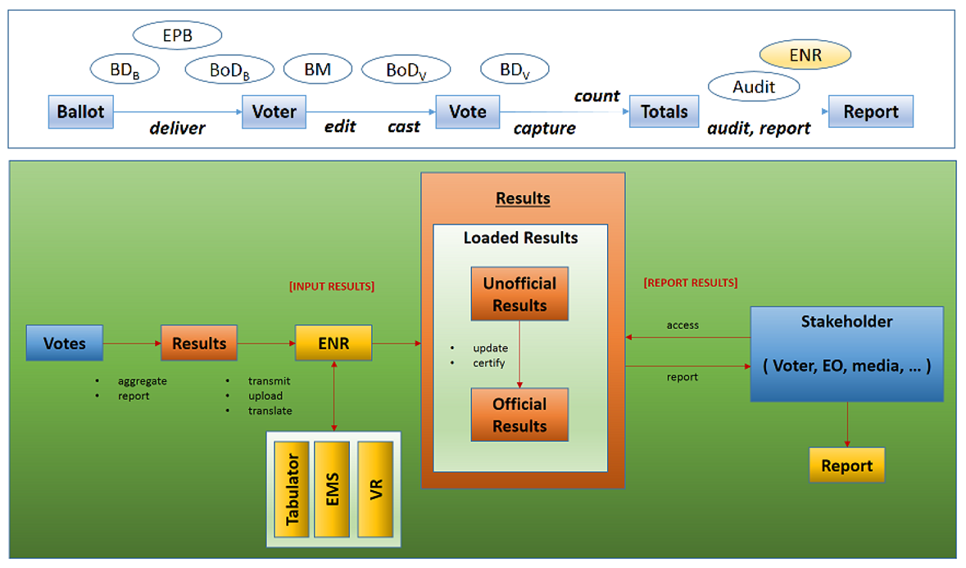

The primary purpose of election-night reporting (ENR) is to provide election results to election results consumers (election stakeholders, voters, public, media, and others). Election results represent the total counted votes from each reporting context (precincts, county, etc.) exercised in a state. An ENR tool generally operates from the highest-level reporting context (e.g., state or county). Results may reach the ENR in many possible ways depending on the election processing (distributed, centralized), dominant voting type (absentee only vs. mixture), state laws (deadlines for accepting/processing absentee, provisional ballot types), reporting abilities they are designed to support (incremental, batch; before, during, after election/polls-closed). Typically, initial uploads of results (by EOs) are provided to the ENR and may be updated as additional results or corrected errors are processed. ENR tools may provide users with overall results process completion information indicating what results have been received, are complete, and so forth. Results are finalized and certified after official canvassing which reviews unofficial results after all are loaded and any corrections are made. ENR tools involve the coordination of a number of factors affecting their operation and implementation. They must be prepared to process and provide data accurately, securely, and without loss of service throughout the entire reporting process and under heavy upload or access periods. They must be able to receive, resolve, integrate and manage results data with respect to a number of different sources (systems: tabulator, EMS, VR; reporting-contexts: precinct, county), transport methods (physical; logical/remote: modem, wired, wireless), data formats (CDF, XML, CSV, …), codings (contest, county), and destinations (published web, data subscribers: media, stake-holders). All throughout the security, integrity, and reliability of the data and process should be maintained. ENR implementations may exist standalone or may be embedded inside other systems (such as an EMS). They may also access other systems to obtain results data or context data (such as voter turnout, voter-specific information from a VR system). They may be implemented using a variety of architectures and approaches ranging from standalone, on-site systems to distributed, cloud-based solutions. In all cases, at minimum, they enable users to generate reports per reporting context. Beyond that, many other data interaction, filtering, interpretation, and reporting options are available. Data formats may be used both on the input and output sides, enabling both results input/uploading as well as results access/download via specific formats.

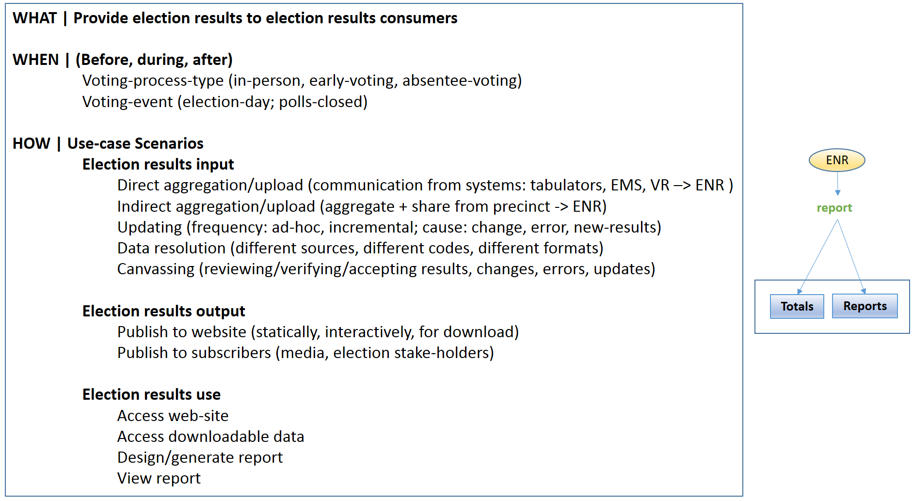

Next Generation VVSG Structure

Introduction

This section contains six subsections that summarize an approach to developing standards for emerging voting system technologies based on a structure of principles and guidelines.
In order to illustrate the details of this structure based on high level principles, we have focused our analysis, in this section, on the human factors of voting systems. It is our intention is that it will serve as a model for developing standards that support security, commercial-off-the-shelf hardware, software, and other aspects of voting systems, while at the same time be responsive to the evolving technology landscape.
This section is intended to help elicit feedback from the election community on the future structure and scope of the voting standards. Together with use case scenarios, they drive gap analysis as well.

Request for Feedback

Specifically, we are requesting your feedback on this approach to structuring the Next Generation VVSG requirements.

Please consider these questions:
- Is this organization based on high level principles and guidelines useful to you? Why? How would you use a standards document structured in this way?
- Is the proposed document format style in Subsection 4 useful?
- Do you have suggestions for improvement? Is something missing?
- Is the analysis helpful?
- What do you think the next steps should be?

Overview

The five subsections include:
- Usability and accessibility principles and guidelines.
- Analysis of the human factors challenges in developing standards for emerging technologies for voting systems.
- A set of tables containing voting system requirements reorganized under the principles and guidelines which have been annotated to identify gaps and possible updates. This also shows how other accessibility standards can be integrated with the voting system requirements. It is a baseline that will serve to drive feedback from the election community. We expect to see lots of changes as we move forward.
- Illustration of how the design of structure of the standards could provide a more intuitive way for election officials as well as advocates, developers, and test labs to find, understand, and navigate the guidelines, requirements, and test assertions to find the information they need.
- Example of how an Election Official (EO) might use the new structure when preparing to procure an electronic ballot marking tablet through a mockup of a subset of the requirements under Principle 3: Marked as Intended. This mockup is based on the requirements reorganized as in the tables in number 3 above.

1. Usability and Accessibility Principles and Guidelines

Principle 1: Equivalent and consistent

All voters have access to mark and cast their ballot as intended, regardless of their abilities, without discrimination.
1.1 Provide voters with a consistent experience of the voting process in all modes of voting
1.2 Provide voters with equivalent information and options in all modes of voting.

Principle 2: Cast as marked

Ballots are cast as marked, both secretly and privately.
2.1 The voting process shall preserve the secrecy of the ballot.
2.2 The voting system must ensure that ballot selections, interface options, voter identity and information about voters are kept private.
2.3 The voting system supports the voter in marking the ballot accurately
2.4 The voting process helps voters avoid errors that invalidate their ballot, including blank ballots, undervotes, overvotes, and marginal marks.

Principle 3: Marked as intended

Ballots are presented in a clear, understandable way, and is operable by all voters.

3.1 | Perceivable | The default system settings for displaying the ballot work for the widest range of voters, and voters can adjust settings and preferences to meet their needs.
3.2 | Operable | Voters and poll workers must be able to use all controls accurately, and all ballot changes are made with the direct control of the voter.
3.3 | Understandable | Voters can understand all information as it is presented.
3.4 | Robust | The voting system’s hardware and accessories support usability and accessibility requirements while protecting voters from harmful conditions.

Principle 4: Tested for usability

Meets performance standards for usability and accessibility.

4.1 | Summative Usability Testing | Summative usability tests are conducted using a wide range of voters and poll workers, including those with and without disabilities.

Principle 5: Meets web accessibility standards

Browser-based systems meet web accessibility standards in addition to voting standards.

5.1 | Meets web-accessibility standards | When a voting system uses standard web software platforms (HTML or native apps), the voting system meets all requirements in WCAG 2.0 Level AA any applicable requirements in the VVSG.

2. Human Factors Analysis

Human Factors Challenges

Human factors is a key to successful design of modern election systems. Standards supporting usability and accessibility of these systems need to integrate emerging technologies with existing standards, keeping in mind the following:
- Core human factors requirements remain relevant (e.g., use of color, contrast, audio, and tactile controls),
- Must incorporate latest research findings, as indicated by the EAC’s Accessible Voting Technology Initiative (AVTI) and updated standards,
- Take into account advances in devices, interfaces, and interactions, and
- Leverage these innovations for all voters without stifling additional innovation.

Incorporate Latest Research

- Use existing standards, and highlight legal implications, i.e. Web Content Accessibility Guidelines (WCAG) 2.0, ADA Accessibility Guidelines (ADAAG), Section 508 Refresh),
- Incorporate promising results of AVTI research (e.g., plain language and plain interaction guidelines, font specifications), and
- Integrate with security, software/hardware, interoperability, and other requirements.

New Devices: Beyond Kiosks

- Accommodate universally designed single voting systems,
- Integrate home desktop computers and laptops for remote ballot marking,
- Include tablet computers for ballot marking and electronic pollbooks, and
- Consider small form factors for representing ballot selections (e.g. QR codes).

New Interfaces

- Small form factor (e.g., ballot content amount, ballot layout, minimum screen size)
- Screen orientation
- Electronic forms (web-based and pdf)
- Ballot selection representation (e.g., QR code, optical character recognition (OCR))

New Interactions

- Touchscreen gestures (e.g., navigation, zoom, coordination with screen readers)
- Personal assistive technology (PAT) (e.g., screen readers, braille readers)
- Onscreen keyboard use
- Magnification and zoom
- Mode switching
- Personalization
- Eye tracking
- System feedback (e.g., mobile device vibrations)

3. Usability and Accessibility Requirements Analysis

[Note: In this initial analysis, we have annotated gaps where new requirements are needed and where VVSG 1.1 requirements need to be updated or removed. These annotations are beneath each corresponding guideline or requirement, and are highlighted within square brackets.]
[Note: We expect feedback from the Constituency Groups, especially HFCG to identify gaps and improvements for the requirements.]

PRINCIPLE 1: EQUIVALENT AND CONSISTENT
All voters have access to mark and cast their ballot as intended, regardless of their abilities, without discrimination.

Requirement | VVSG | Accessibility Standard
All voters have access without discrimination  [Remove: covered by new principles] | 3.1.1.a | [ voting specific ]
Voting is accessible to people with disabilities  [Remove: covered by new principles] | 3.1.1.a.i | [ voting specific ]

GUIDELINE 1.1: Provide voters with a consistent experience of the voting process in all modes of voting

Requirement | VVSG | Accessibility Standard
Presentation in all languages supported | 3.2.7.a | [ voting specific ]
Records support auditing in English | 3.2.7.a.ii | [ voting specific ]
Acc-VS integrated into complete voting system | 3.3.1.a | [ voting specific ]
If a Acc-VS system produces a paper ballot, the Acc-VS needs to be able to read it  [Note: Might need updating in context of new technology and ballot forms] | 3.3.1.e | [ voting specific ]
All modes must have same capabilities as visual interface | 3.3.3.b.i | [ voting specific ]  Related to 508: 1194.31
Provide ballot activation for blind voters | 3.3.3.d | [ voting specific ]  Related to 508: 1194.31
Provide ballot submission/verification for blind voters  [Note: This includes for remote ballot marking, see also Principle 3] | 3.3.3.e | [ voting specific ]  Related to 508: 1194.31
Mode of non-manual input equivalent to tactile mode | 3.3.4.b | [ voting specific ]  Related to 508: 1194.31
Documentation of access functions | 3.3.1.a.i | [ voting specific ]
VVPAT in same language as ballot  [Revisit: VVPAT is a very specific implementation that should fall under more general existing and additional requirements, that would include other forms of verification, including new technology] | 7.8.6.c, i, ii | [ voting specific ]
VVPAT meets all accessibility requirements  [Note: Generalize] | 7.8.7.a | [ voting specific ]
[Remote ballot marking, if in scope, must be addressed]

GUIDELINE 1.2: Provide voters with equivalent information and options in all modes of voting.

Requirement | VVSG | Accessibility Standard
Verify paper record with access features | 3.2.2.1.g | [ voting specific ]
Paper records support low vision | 3.2.5.g | [ voting specific ]
Present all content/warnings in other languages | 3.2.7.a.ii | [ voting specific ]
Acc-VS must also present all instructions, warnings, error and other messages, and contest choices to voter | 3.3.1.b | [ voting specific ]  Related to 508: 1194.31
Audio synchronized to visual display with same information | 3.3.2.c | [ voting specific ]  Related to 508: 1194.31
Audio synchronized to visual display | 3.3.2.c.ii | [ voting specific ]  Related to 508: 1194.31
All sound cues accompanied by visual cue | 3.3.6.b | 508: 1194.31.c
VVPAT additional requirements  [Generalize] | 7.8.6.a | [ voting specific ]
VVPAT provides accessibility for visual impairments and non-written language  [Generalize] | 7.8.7.b | [ voting specific ]

PRINCIPLE 2: CAST AS MARKED
Ballots are cast as marked, both secretly and privately.

GUIDELINE 2.1: The voting process shall preserve the secrecy of the ballot.

Requirement | VVSG | Accessibility Standard
Protect secrecy of the ballot | 3.1.1.c | [ voting specific ]
No receipt that provides proof of how voted | 3.2.3.1.e | [ voting specific ]
No recording of use of alternative language | 3.2.3.2.a | [ voting specific ]
No recording of access features | 3.2.3.2.b | [ voting specific ]
VVPAT Secrecy on spooled paper  [Generalize to new forms of ballot selections and verification ,e.g., QR codes, OCR, list of choices.] | 7.8.5.b | [ voting specific ]
VVPAT no recording of order of voters  [Generalize] | 7.8.5.c | [ voting specific ]
VVPAT unique identifiers not memorable  [Generalize] | 7.8.5.f | [ voting specific ]
VVPAT protected as a ballot box  [Generalize] | 7.8.5.g | [ voting specific ]

GUIDELINE 2.2: The voting system must ensure that ballot selections, interface options, voter identity and information about voters are kept private.

Requirement | VVSG | Accessibility Standard
No ability to determine content, with or without voter's cooperation | 3.1.1.c.i | [ voting specific ]
Prevent other from determining content of ballot | 3.2.3.1.a | [ voting specific ]
Privacy in marking and casting ballot | 3.2.3.1.b | [ voting specific ]
Audio audible only to voter | 3.2.3.1.c | 508: 1194.25.e
Warnings preserve privacy of voter and confidentiality of ballot | 3.2.3.1.d | [ voting specific ]
Voter can disable visual or audio output | 3.3.2.c.i | [ voting specific ] or related to WCAG 1.1

VVPAT preserve voter privacy during recording, verifying, auditing  [Generalize] | 7.8.5.a |  | [ voting specific ]
VVPAT stored to preserve privacy  [Generalize] |  | 7.8.5.d | [ voting specific ]
VVPAT preserves privacy of alternative languages  [Generalize] |  | 7.8.5.e | [ voting specific ]

GUIDELINE 2.3: The voting system supports the voter in marking the ballot accurately

Requirement | VVSG | Accessibility Standard
Each ballot shall accurately capture selections made by the voter | 3.1.1.b | [ voting specific ]
Support voters in completing their ballots | 3.2.1.a | [ voting specific ]
The voting system does not contribute to errors | 3.2.1.b | [ voting specific ]
Voting system provides instructions | 3.2.3.a | [ voting specific ]
Ballot designed with clarity | 3.2.4.e | [ voting specific ]
No contest across 2 pages or columns  [Consider implications of this in context of new interfaces and interactions] | 3.2.4.e.i | [ voting specific ]
Indicate maximum number of choices in a contest | 3.2.4.e.ii | [ voting specific ]
Consistent relationship between name and voting mechanism | 3.2.4.e.iii | [ voting specific ]
Provide unambiguous feedback on voter choices | 3.2.6.b | [ voting specific ]
Prevent selection of more than allowed (overvotes) | 3.2.2.1.a | WCAG 3.3.1, 3.3.3-4

GUIDELINE 2.4: The voting process helps voters avoid errors that invalidate their ballot, including blank ballots, undervotes, overvotes, and marginal marks.

Requirements for Notification and Warnings

Requirement | VVSG | Accessibility Standard
Notification of casting | 3.2.2.d | WCAG 3.3.1, 3.3.3-4
Screen: Notification of failure to cast | 3.2.2.1.f | WCAG 3.3.1, 3.3.3-4
PCOS: Notification of failure to cast | 3.2.2.2.g | WCAG 3.3.1, 3.3.3-4
PCOS: Notification of blank ballot | 3.2.2.2.c | WCAG 3.3.1, 3.3.3-4
Notification of effect of overvoting | 3.2.2.a | WCAG 3.3.1, 3.3.3-4
PCOS identifies number of overvoted contests | 3.2.2.2.a | WCAG 3.3.1, 3.3.3-4
PCOS identified specific contests (optional) | 3.2.2.2.b | WCAG 3.3.1, 3.3.3-4
Provide feedback on undervoted contests | 3.2.2.1.b | WCAG 3.3.1, 3.3.3-4

Requirements for Error Correction

Requirement | VVSG | Accessibility Standard
Can cast an undervoted ballot without correction | 3.2.2.b | WCAG 3.3.1, 3.3.3-4
Allow correction of a undervote or overvote | 3.2.2.c | WCAG 3.3.1, 3.3.3-4
Opportunity to correct | 3.2.2.1.c | WCAG 3.3.1, 3.3.3-4
Allow to change a vote within a contest | 3.2.2.1.d | WCAG 3.3.1, 3.3.3-4
PCOS allows voter to correct ballot | 3.2.2.2.d | WCAG 3.3.1, 3.3.3-4
Correct or submit ballot with marginal marks | 3.2.2.2.e,i-iii | WCAG 3.3.1, 3.3.3-4

PRINCIPLE 3: MARKED AS INTENDED
Ballots are presented in a clear, understandable way,
and is operable by all voters.

GUIDELINE 3.1: Perceivable - The default system settings for displaying the ballot work for the widest range of voters, and voters can adjust settings and preferences to meet their needs.

Requirement | VVSG | Accessibility Standard
Ballot shall be presented to the voter in a manner that is clear and usable  [Remove: covered by new principle/guidelines] | 3.1.1.b.i | WCAG 1

Requirements for Custom Settings

Requirement | VVSG | Accessibility Standard
Set customization to default between participants | 3.2.5.b | [voting specific]. Related to 1194.25.f
Voter should be able to reset their own customized settings | 3.2.5.c | [voting specific]. Related to 1194.25.f
Selection of languages | 3.2.7.a.i | [ voting specific ]

Requirements for All Visual Interfaces

Requirement | VVSG | Accessibility Standard
Text contrast ratio no less than 10:1 (optical scan)  [Consider generalizing to all interfaces voters and poll workers use] | 3.2.2.2.f.ii | WCAG 1.4.3 (exceeds)
Minimum contrast for figure to ground of 10:1 | 3.2.5.h.i | WCAG 1.4.3 (exceeds)
Use color in conventional ways | 3.2.4.f | WCAG 1.4.1
Text displayed in a readable font (as specified in 3.2.5.d.i-iii)  [Consider new research and more specificity of font size as well as new small form factor devices] | 3.2.5.d | WCAG 1.4.8 (AAA)
Use sans serif font  [Update to be mandatory, based on new research] | 3.2.5.f | n/a
No information communicated with color alone | 3.2.5.i | WCAG 1.4.1

Requirements for Electronic Visual Interfaces

Requirement | VVSG | Accessibility Standard
Must show all information in a minimum of two text sizes (as specified in 3.2.5.e.i-ii)  [Consider new research and specificity of font size as well as new small form factor devices] | 3.2.5.e | WCAG 1.4.4
High contrast view either as initial screen or option | 3.2.5.h.ii | WCAG 1.4.3 and 1.4.6
Voters can adjust color, contrast | 3.3.2.a | WCAG 1.4.8
Minimum two contrast/color options | 3.3.2.a.i | WCAG 1.4.3 and 1.4.6
[Consider new, smaller devices and determine if new requirements are needed, eg., for zoom and magnification]

Requirements for Print Interfaces
[Discuss and revise for print interfaces, issue: paper is inherently not accessible]

Requirement | VVSG | Accessibility Standard
Printed ballot available in at least two font sizes | 3.2.5.g.i | WCAG 1.4.4, 1.4.8 (AAA)
System may provide optical or electronic magnification for paper ballots | 3.2.5.g.ii | WCAG 1.4.8 (AAA)
VVPAT font sizes  [Generalize]  [Consider new technology, may need additional requirements if paper cannot be avoided.] | 7.8.6.b | WCAG 1.4.4, 1.4.8 (AAA)

Requirements for Audio Interfaces

Requirement | VVSG | Accessibility Standard
Initial volume between 60 and 70 dB SPL | 3.3.3.c.iv | Related to 508: 1194.25.e and f
Voter can control volume | 3.3.3.c.v | WCAG 1.4.2, 508: 1194.25.f
System reproduces audible speech frequencies | 3.3.3.c.vi | WCAG 1.4.2
Audio comprehensible w/ good hearing and language skills | 3.3.3.c.vii | Related to 508: 1194.25.f
Voter can control rate of speech | 3.3.3.c.viii | n/a
Acc-VS shall incorporate audio features listed under Requirement 3.3.3.c | 3.3.6.a | [ voting specific ]
For voters with low reading proficiency in English, use audio interface requirement 3.3.3 b | 3.3.8.a | [ voting specific ]
[New requirements for design on new devices and personal assistive technology such as voiceovers and system feedback via vibration]

Requirements for Mechanical or Tactile Controls

Requirement | VVSG | Accessibility Standard
Controls differentiate by shape and color | 3.3.2.b | WCAG 1.3.3
Mechanical keys tactilely discernable w/o activation | 3.3.3.f | 508: 1194.23.k(1)
Status of toggle keys discernable through touch or sound | 3.3.3.g | 508: 1194.23.k(4)

Requirements for Alternative Languages

Requirement | VVSG | Accessibility Standard
Allow voter to change language and preserve votes at any time. Present language name/label in native language. | 3.2.7.a.i | [ voting specific ]
Record all voter records in English | 3.2.7.a.iii | [ voting specific ]

GUIDELINE 3.2: Operable - Voters and poll workers must be able to use all controls accurately, and all ballot changes made with the direct control the voter.
[In general, New requirements for new devices, e.g. tablets and for new modes of interaction, e.g. gestures, are needed.]

Requirements for All Interface Controls

Requirement | VVSG | Accessibility Standard
Navigation between contests in all modes | 3.2.2.1.e | [ voting specific ]  Related to WCAG 2.4.5
No voter speech required for operation | 3.3.9.a | 508: 1194.31.e
Mechanisms designed to prevent accidental activation | 3.2.6.c | Related to 508: 1194.31.f and 508: 1194.23.k(1)

Requirements for Controls within reach

Requirement | VVSG | Accessibility Standard
Minimum clear floor space | 3.3.5.a | ADAAG¹
Allow room for an assistant to the voter | 3.3.5.b | ADAAG
Labels, keys, etc all visible from wheelchair height | 3.3.5.c | ADAAG
Requirements for forward approach without reach obstruction | 3.3.5.1.a | ADAAG
Requirements for forward approach with reach obstruction | 3.3.5.1.b | ADAAG
Requirements for parallel approach without obstruction reach | 3.3.5.1.c | ADAAG
Requirements for parallel approach with obstruction reach | 3.3.5.1.d | ADAAG
[Work with Access Board to incorporate new wheelchair anthropometry and lessons learned in practice]
VVPAT usable in same position  [Generalize, may need additional requirements to support usable position.] | 7.8.6.d | [ voting specific ]

¹ ADA Accessibility Guidelines (ADAAG) contains requirements for accessibility to buildings and facilities by individuals with disabilities under the Americans with Disabilities Act (ADA) of 1990. https://www.access-board.gov/guidelines-and-standards/buildings-and-sites/about-the-ada-standards/background/adaag

Requirements for Print Interfaces

Requirement | VVSG | Accessibility Standard
Optical scan - Target areas at least 3 mm | 3.2.2.2.f.i | 508: 1194.31.f
VVPAT allows voter to see whole record  [Generalize] | 7.8.6.e | [ voting specific ]
VVPAT page numbers  [Generalize] | 7.8.6.f | [ voting specific ]
[Consult with researchers and advocacy groups on scope and potential improvements in or elimination of paper ballot interaction]

Requirements for Electronic Interface Controls

Requirement | VVSG | Accessibility Standard
Electronic ballot interface shall not require page scrolling  [Should be clarified to convey the concept that contest information off the screen is obvious to voters.] | 3.2.6.a | [ voting specific ]
Minimum sizes of touch areas | 3.2.6.c.i | Related to 508: 1194.31.f
[New requirements for virtual keyboards and mode switching for new devices]

Requirements for Controls

Requirement | VVSG | Accessibility Standard
Provide an Audio Tactile Interface (ATI) | 3.3.3.b | [ voting specific ]  Related to 508: 1194.25 and 508:1194.23.k.1-4
Keys operable with one hand and reduced dexterity | 3.3.4.c | 508: 1194.23.k.1
No controls that require voter's body to complete circuit | 3.3.4.d | Related to 508: 1194.24.d
No repetitive effect as a result of holding down button | 3.2.6.c.ii | 508: 1194.23.k(3)
[Requirements for new interaction modes such as eye-tracking both in polling place and efficient design to support eye-tracking PAT]

Requirements for Audio Controls

Requirement | VVSG | Accessibility Standard
Voter can repeat audio | 3.3.3.b.ii | WCAG 1.4.2
Voter can pause and resume audio | 3.3.3.b.iii | WCAG 1.4.2
Voter can skip audio reading of contest | 3.3.3.b.iv | WCAG 1.4.2
Voter can skip audio reading of referendum | 3.3.3.b.v | WCAG 1.4.2

Requirements for System Response to Voter Actions

Requirement | VVSG | Accessibility Standard
Maximum initial system response time | 3.2.6.1.a | WCAG 2.2.1
Maximum completed system response time to record a single vote | 3.2.6.1.b | WCAG 2.2.1
Maximum completed system response time during voter interaction with the visual display | 3.2.6.1.c | WCAG 2.2.1
Warn about long response times | 3.2.6.1.d | WCAG 2.2.1
Warn about voter inactivity | 3.2.6.1.e | WCAG 2.2.1
Alert after expiration of voter activity | 3.2.6.1.f | WCAG 2.2.1

GUIDELINE 3.3: Understandable – Voters can understand all information as it is presented.
[New requirements for plain interaction based on recent research to better support low literacy and people with cognitive limitations. Simple, directed interaction will help all voters, as well.]

Requirements for all instructions, alerts and warnings

Requirement | VVSG | Accessibility Standard
Warnings and alerts must be distinguishable from other information. | 3.2.4.c.i | WCAG 3.3.1, 3.3.3-4
Separate text instructions visually, and temporally for audio | 3.2.4.c.iv | WCAG 3.3.1, 3.3.3-4
No bias in instructions | 3.2.4.d | [ voting specific ]
Instructions should be located near where needed | 3.2.4.e.iv | WCAG 3.3.2
Icons must have labels | 3.2.4.g | WCAG 1.1, 2.4.6
Include clear, complete, and detailed instructions for setup, polling, and shutdown. | 3.2.8.1.c | [ voting specific]  Related to 508:1194.41
Verification instructions on the voting machine | 7.8.6.g | [ voting specific ]
[Requirements based on language/low literacy research on voting instructions]

Requirements for Plain Language

Requirement | VVSG | Accessibility Standard
Provide instructions for all operations | 3.2.4.a | WCAG 3.3.2
Provide means to get help from system at any time | 3.2.4.b | WCAG 3.3.5 (AAA)
Write instructions in plain language | 3.2.4.c | WCAG 3.1.3-5 - 3.1.6 (AAA)
State condition first, then action to be performed | 3.2.4.c.ii | n/a
Use familiar words, avoid technical words | 3.2.4.c.iii | WCAG 3.1.3-4, 3.1.5-6 (AAA)
Tell voters correct action, not what to avoid | 3.2.4.c.v | n/a
Address voter directly (no passive voice) | 3.2.4.c.vi | n/a
Avoid gender-based pronouns | 3.2.4.c.vii | n/a
Poll worker instructions in plain language | 3.2.8.a | n/a
Provide support to voters with cognitive disabilities  [Now covered here and by font, audio, and others, need to be revisited.] | 3.3.7.a | n/a  Related to 508: 1194.31
[Requirements based on language/low literacy research for voting]

[Requirements for instructions for navigation/selection on new devices]

GUIDELINE 3.4: Robust - The voting system’s hardware and accessories support usability and accessibility requirements while protecting voters from harmful conditions.

Requirements for Electronic Displays

Requirement | VVSG | Accessibility Standard
Electronic display screen technical requirements | 3.2.5.a, 3.2.5.a.ii-vii | n/a
Flicker frequency | 3.2.5.a.i | 508: 1194.25.i

Requirements for Personal Assistive Technology (PAT)

Requirement | VVSG | Accessibility Standard
PAT not necessary to operate Acc-VS | 3.3.1.c | 508: 1194.25
Secondary method for identification is necessary if biometrics are used | 3.3.1.d | 508: 1194.25d
ATI audio uses standard jack  [And jack is discernable by touch, based on industry ATM standards.] | 3.3.3.c.i | 508: 1194.25.e
Requirements if ATI uses a telephone style handset | 3.3.3.c.ii | 508: 1194.23.h
Standard jack for PAT, allow it to work like an ATI | 3.3.4.a | Related to 508: 1194.25.e
[Additional requirements for improved support for voters PAT in the polling place, where possible.]
[Requirements for PAT for voting at home, such as remote ballot marking. WCAG 2.0 may be sufficient, but some additional voting specific requirements might also be needed.]

Requirements for Safety

Requirement | VVSG | Accessibility Standard
Voting system designed to eliminate hazards to personnel or equipment | 3.2.8.2.a-b | UL 60950
Sanitized headphones for each voter | 3.3.3.c.iii | n/a
Voting system shall not cause EM interference with hearing aids | 3.3.6.c | 508: 1194.23.h  508: 1194.23.i

PRINCIPLE 4: TESTED FOR USABILITY
Meets performance standards for usability and accessibility.

GUIDELINE 4.1 – Conduct summative usability tests using a wide range of voters and poll workers, including those with and without disabilities.

Requirements for usability testing

[Additional guidance for improving quality of vendors’ summative usability tests, formative testing, and guidance for election officials. Additional ISO standards in 2506n series.]
[Could extend to testing of voter information websites by jurisdictions, such as for remote ballot marking.]

Requirement | VVSG | Accessibility Standard
High level of usability | 3.2.a | n/a
Vote effectively, efficiently, comfortably | 3.2.b | n/a
Conduct summative usability tests with individuals of the general population to test system setup, operation, and shutdown | 3.2.7.a.iv | n/a
The voting system’s setup, operation, and shutdown is relatively easy to use for poll workers to learn, understand, and perform | 3.2.8.1.a | [ voting specific ]
Usability for poll workers | 3.2.8.1.b | [ voting specific ]
Submit usability report of machine for general population. | 3.3.10.a | n/a
Conduct summative usability tests for all languages. | 3.2.7.a.iv | [ voting specific ]
Conduct summative usability tests with blind users. | 3.3.3.a | n/a  Related to 508: 1194.31
Submit usability report of Acc-VS tested with low vision voters | 3.3.10.b | n/a  Related to 508: 1194.31
Submit usability report of Acc-VS tested with low dexterity voters | 3.3.10.c | n/a  Related to 508: 1194.31

PRINCIPLE 5: MEETS WEB ACCESSIBILITY STANDARDS
Browser-based systems meet web accessibility
standards in addition to voting standards.

GUIDELINE 5.1: When a voting system uses standard web software platforms (HTML or native apps), the voting system meets all requirements in WCAG 2.0 Level AA in addition to those in the VVSG.

[Reference to other accessibility standards is a new approach. Investigate how to best integrate this into the VVSG. Can potentially simplify/clarify the accessibility requirements.]

4. Structure of the Standard

Proposed Format

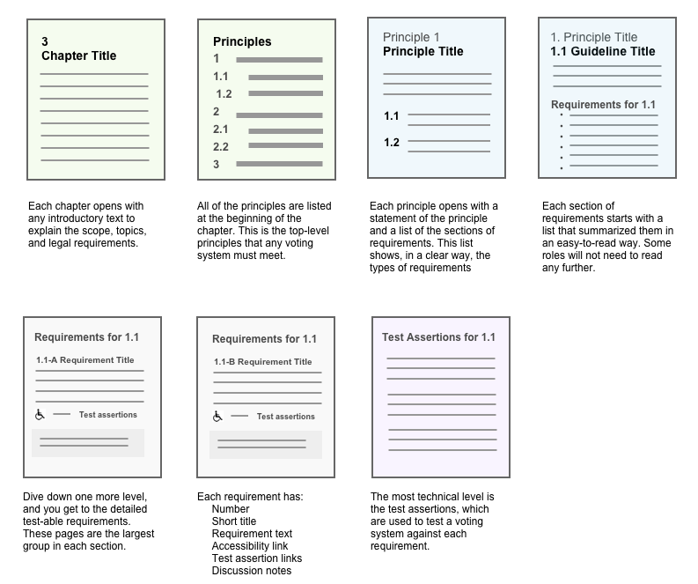

Clear Sections of Information
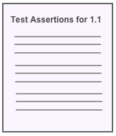
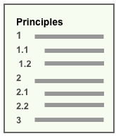
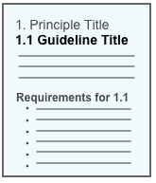
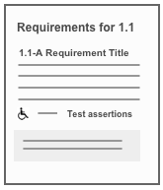
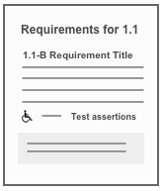

Many different people with different roles use voting standards, from the highest level of election administration to the test labs. They can each find the right level of detail for them to understand how the requirements support elections. Further, this hierarchical structure allows both a Word document and web pages to be generated so the reader can just pull out the sections they need from the document or navigate the web pages.

Navigation in the Web Page View

As you jump into the principles, you start on an opening page with a statement of the principle and a list of the sections of requirements. This list shows, in a clear way, the types of requirements
Click on a guideline and you see a list of all of the requirements that systems must meet. They are summarized in an easy-to-read list.
This page is helpful for those already familiar with the VVSG. Some will not need to read any further.
Dive down one more level, and you get to the detailed test-able requirements. These pages are the largest group in each section.
Each requirement has:
- Number
- Short title
- Requirement text
- Accessibility link
- Test assertion links
- Discussion notes

5. Example using Principle 3

Scenario: Election Official (EO) would like to procure new electronic ballot marking system (EBM) on a commercially available tablet. The system needs to be usable and accessible by all voters at the polling place.
The EO will use the new voting system standard, which has been updated for new devices, as guidance to be sure to the tablet will meet voters’ needs. She checks each principle, drilling down as needed for this specific device.
For the purpose of this example, we show only a small selection of requirements associated with Principle 3, and use VVSG 1.1, in the new principle and guideline structure as a baseline. See the HF Analysis section in this package for possible areas where requirements will be changing as we discuss with the election community. The diagram below shows an overview of this example.
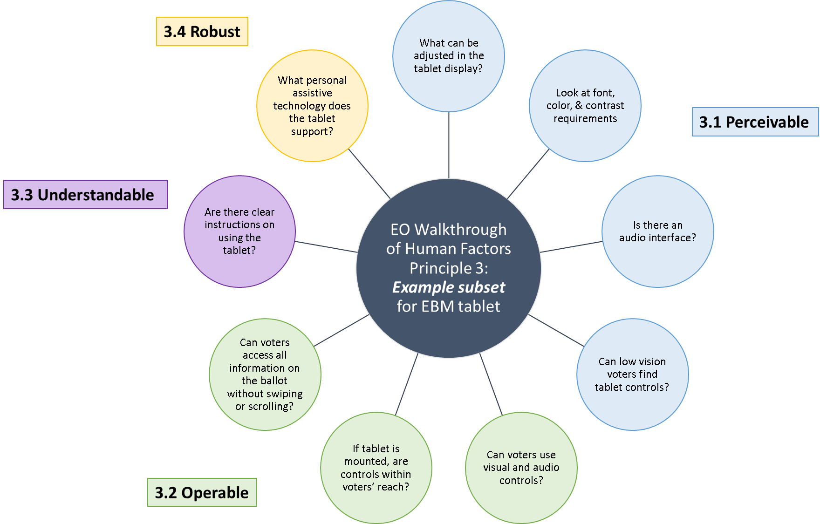
We show the EO walkthrough with annotations in purple within brackets “[EO:…].”

Principle 3: MARKED AS INTENDED
Ballots are presented in a clear, understandable way, and is operable by all voters.

3.1 Perceivable - The default system settings for displaying the ballot work for the widest range of voters, and voters can adjust settings and preferences to meet their needs.
[EO: What can be adjusted in the tablet’s display? They will all need to be specified in the RFP. I should look at those requirements.]

Requirements
325b Requirements for Custom Settings
Any aspect of the voting system voter interface that is adjustable by either the voter or poll worker, including font size, color, contrast, audio volume, or rate of speech, shall automatically reset to a standard default value upon completion of that voter's session. For the Acc-VS with an electronic image display, the aspects include synchronized audio/video mode and non-manual input mode.
1194.25.f Test assertions: 315
Discussion: This ensures that the voting system presents the same initial appearance to every voter.

[EO: I see some requirements about font, color, and contrast. The system on the tablet needs to follow those, too.]
325f Requirements for All Visual Interfaces
Text intended for the voter shall be presented in a sans serif font.
Test assertions: 315
Discussion: In general, sans serif fonts are easier to read on-screen, they look reasonably good when their size is reduced, and they tend to retain their visual appeal across different platforms.
325i Requirements for All Visual Interfaces
Color coding shall not be used as the sole means of conveying information, indicating an action, prompting a response, or distinguishing a visual element
WCAG 1.4.1 Test assertions: 315
Discussion: While color can be used for emphasis, some other non-color mode must also be used. This could include shape, lines, words, text, or text style. For example, an icon for stop can be red enclosed in an octagon shape. Or, a background color can be combined with a bounding rule and a label to group elements on the ballot.
[EO: An audio interface for the tablet is needed. What do I need to look for?]
336a Requirements for Audio Interfaces
The Acc-VS shall incorporate the features listed under Requirement 3.3.3 c for voting systems that provide audio presentation of the ballot.
Test assertions: 325
Discussion: Note especially the requirements for volume initialization and control.
[EO: How does the EBM tablet allow a low vision person to find the controls? Or, is there an add-on set of mechanical controls?]
332b Requirements for Mechanical or Tactile Controls
Groups of buttons and controls which perform different functions on the Acc-VS shall be distinguishable by both shape and color. This applies to buttons and controls implemented either on-screen or in hardware. This requirement does not apply to sizeable groups of keys in wide use by individuals with disabilities, such as a full alphabetic keyboard when used for purposes other than basic navigation and selection (e.g. entering a write-in candidate name).
WCAG 1.3.3 Test assertions: 322
Discussion: The redundant cues assist those with low vision. They also help individuals who may have difficulty reading the text on the screen, those who are blind but have some residual vision, and those who use the controls on an Acc-VS because of limited dexterity. While this requirement is primarily focused on those with low vision, a feature intended primarily to address one kind of disability may very well assist voters with other kinds.

3.2 Operable - Voters and poll workers must be able to use all controls accurately, and all ballot changes are made with the direct control of the voter.
[EO: How does the voter navigate the ballot on the EBM tablet? I’ve looked over the voter controls for visually going through the ballot, but are the audio controls easy to operate, too?]

Requirements
3221e Requirements for All Interface Controls
The electronic ballot interface shall provide navigation controls that allow the voter to advance to the next contest or go back to the previous contest before completing a vote on the contest(s) currently being presented (whether visually or aurally).
WCAG 2.4.5 Test assertions: 312
Discussion: For example, voters should not be forced to proceed sequentially through all the contests before going back to check their votes within a previous contest.
[EO: Do I need to worry about the controls being within a voter’s reach? The tablet is portable, but if it will be mounted in a voting booth, it will have to be reachable in that booth.]
335a Controls within reach
The Acc-VS shall provide a clear floor space of 30 inches minimum by 48 inches minimum for a stationary mobility aid. The clear floor space shall be designed for a forward approach or a parallel approach.
ADAAG Test assertions: 324
[EO: The tablet allows voters to swipe to scroll, is this enough? Does it work for everyone?]
326a Requirements for Electronic Interface Controls
The electronic ballot interface shall not require page scrolling by the voter. (NOTE: this requirement needs to adapted to new devices to ensure voters can navigate and not miss part of a contest.)
Test assertions: 316
Discussion: That is, the page of displayed information must fit completely within the physical screen presenting it. Scrolling is not an intuitive operation for those unfamiliar with the use of computers. Even those experienced with computers often do not notice a scroll bar and miss information at the bottom of the page. Voting systems may require voters to move to the next or previous page.
334d Requirements for Controls
The Acc-VS controls shall not require direct bodily contact or for the body to be part of any electrical circuit.
508: 1194.24.d Test assertions: 323
Discussion: This requirement ensures that controls are operable by individuals using prosthetic devices.
3.3 Understandable - Voters can understand all information as it is presented.

Requirements
[EO: Do I have clear instructions on how to operate the EBM tablet?]

324b Requirements for Plain Language
The voting system shall provide a means for the voter to get help directly from the system at any time during the voting session.
WCAG 3.3.5 (AAA) Test assertions: 314
Discussion: The voter should always be able to get context-sensitive help from the system when needed. The purpose is to minimize the need for assistance from the poll worker. Electronic ballot interface systems may provide this with a distinctive help button. In addition to context-sensitive help, any voting system may provide written instructions that are separate from the ballot.
324c Requirements for Plain Language
Instructional material for the voter shall conform to norms and best practices for plain language. (Note: there are specific sub-requirements not listed here. We expect that there will also be requirements for plain “interaction” to help with operation and navigation of the ballot)
WCAG 3.1.3 | WCAG 3.1.4 | WCAG 3.1.5 | WCAG 3.1.6 (AAA) Test assertions: 314
3.4 Robust - The voting systems hardware and accessories support usability and accessibility requirements while protecting voters from harmful conditions.

Requirements

[EO: What additional personal assistive technology can this tablet support?]
(NOTE: an area of research for this standard is the use of PAT in the polling place.)
331c Requirements for Personal Assistive Technology (PAT)
The support provided to voters with disabilities shall be intrinsic to the Acc-VS. Personal assistive devices of the voter shall not be necessary to operate the Acc-VS correctly.
508: 1194.25 Test assertions: 323
Discussion: This requirement does not preclude the Acc-VS from providing interfaces to assistive technology. (See definition of personal assistive devices in Appendix A.) Its purpose is to assure that disabled voters are not required to bring special devices with them in order to vote successfully. The requirement does not assert that the Acc-VS will eliminate the need for a voters ordinary non-interfacing devices, such as eyeglasses or canes.

334a Requirements for Personal Assistive Technology (PAT)
The Acc-VS shall provide a 3.5 mm industry standard jack used to connect a personal assistive technology switch to the Acc-VS. This jack shall allow only switch data to be transmitted to the voting system. The voting system shall accept switch input that is functionally equivalent to tactile input. All the functionality of the Acc-VS (e.g., straight party voting, write-in candidates) that is available through the conventional forms of input, such as tactile, shall also be available through this non-manual input mechanism.
508: 1194.25.e Test assertions: 323
Discussion: This requirement ensures that the Acc-VS are operable by individuals who do not have the use of their hands. Examples of non-manual controls include sip and puff switches. While it is desirable that the voter be able to independently initiate use of the non-manual input mechanism, this requirement guarantees only that the voter can vote independently once the mechanism is enabled.
(Note: Eye tracking might also be another area for supporting non-manual input. In general, requirements for non-manual controls need clarification and updating.)

